**Course Project**

**Abed Tabbalat**

**DSC 640**

**The scenario/Business Problem:**

Due to recent unfortunate airline crashes, the media has been promoting statistics stating air is no longer a safe way to travel. The news and media outlets have been bombarding the public with reports and figures about the trends of airline safety and that things are not looking good. What was previously thought as the safest way to travel, especially when compared to automobiles, is now being presented as one of the most dangerous to the public. But are any of these claims based on facts?

You work for an airline on the data science team as a data analyst and are a resident data visualization expert. You have been tasked with helping multiple groups in the organization combat this negative publicity and help tell the airline's side of the story. There is a fear internally about what this type of media coverage will do to airline sales and how it could impact the future of the company. Not only do they need you to help create some internal communications, but you will also be tasked with what is published to the public and the media.

**Project Task 1: Dashboard**

Your first task is to create an internal dashboard for your peers and data science management team that outlines the facts – what are the stats and what are the trends? Is there any supplemental data that you can use to support that air travel is still in fact the safest? Is there anything politically going on that would cause this type of media attention to be at a peak – remember, this is for an internal review by your peers and management – and will likely spark a lot of discussion for how you approach the next level of discussion with your executive leadership team. Is there anything to show sales are down or are headed that way? Do the safety incidents appear to be in a specific geographic area or by a specific airline every time? Do some analysis of the data you have and look for other sources to see what you can find to help inform your internal team. This project is the first of many building on top of the information you find and will present internally and then externally.

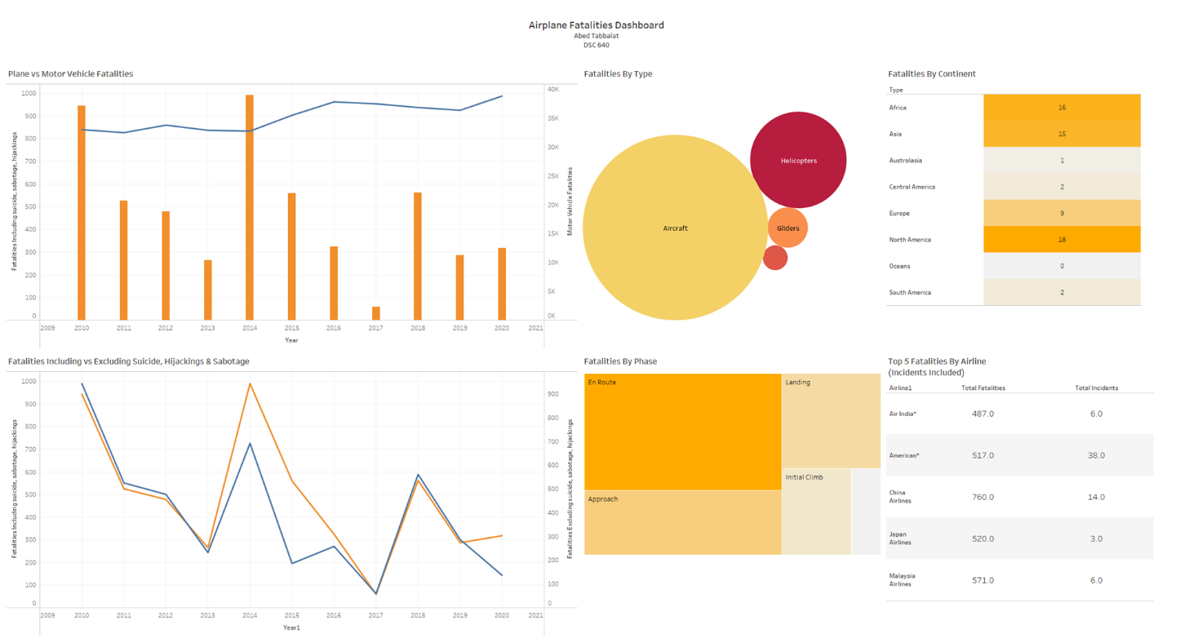

Since the topic is about fatality it is an important topic and therefore, I chose warm colors to keep the attention on the dashboard. The first chart shows a dual axis chart with the bar chart being the fatalities due to airplane crashes and the line are vehicles. I chose this chart to be at the top left since it sends a message that no matter what the airplane fatalities are, it is not as frequent as vehicles.

The chart on the bottom left shows aircraft fatalities for both lines, the orange line includes sabotage, hijackings, and suicide while the blue excludes them. We can definitely see the year 2014 was involved highly with that. Going to the top middle section which is a packed bubble chart, this chart compares fatalities based on the type of airplanes and an aircraft is significantly more than the others such as helicopters, Gliders, etc. The bottom middle chart shows the fatalities by phase which means what was the aircraft’s position when the crash happened, the highest is enroute with second comes approach.

The right side was data that required to use tables since there are so many charts that could be used, and both tables are needed to show where our company stands geographically. The first table shows the number of fatality incidents by continent, the downside is that North America is the highest. The final bottom right table shows the top 5 fatalities by airlines. The far east leads that and American airlines comes in 3rd which is something that requires more detailed explanation.

The dashboard disapproves the media since vehicle fatalities are in the thousands where the airplane fatalities are in the hundreds and those include private planes and cargo planes. Flying is the safest transportation however, if an accident occurs it causes more fatalities. In addition, if we investigate what the reasons are for planes having incidents en route (mechanical failures and such). Implementing additional safety measures could easily counter all the media’s advertisement about air travel.